Kaplan Business School

Energy Poverty Vulnerability in Australia
A Data-Driven Analysis of At-Risk LGAs, Key Drivers and Electricity Price Sensitivity

DATA6000 - Capstone Industry Case Studies
Josiane Januario – ID 1850591

Table of Contents
Executive Summary 3
1. Industry Problem 4
2. Data Processing and Management 4
3. Data Analytics Methodology 6
4. Visualisation and Evaluation of Results 8
5. Recommendations 10
6. Data Ethics and Security 11
7. Reference List 12
Appendix A - Technical Analytics Methodology 14
Appendix B – GitHub 17

Executive Summary

This project analysed the vulnerability of energy poverty in 547 Australian Local Government Areas (LGAs) and used socioeconomic, housing, climate and electricity cost data. Descriptive analysis in Power BI was combined with machine learning techniques in Orange. K-Means identified 51 LGAs with a higher multidimensional vulnerability profile, approximately 92% are from Queensland, Western Australia and the Northern Territory, these LGAs are more exposed to scenarios of increased electricity as analysed, because they have a higher average energy burden than the other LGAs. The project recommends using these results as a decision support tool and to improve data integration and be able to have more detailed research, so that they can have better targeted projects.

Industry Problem
Energy poverty is when a family struggles to pay its energy bill or use essential energy services, such as heating and cooling, without affecting other basic needs. In Australia, about one in five homes is vulnerable or already has at least one energy hardship indicator (ECA 2025). Some families reduce the use of seclusion and refrigeration to avoid bills they cannot pay, so part of the problem may be hidden (RMIT University 2023). However, energy poverty also depends on income factors, housing conditions and socioeconomic situations, not just the price of electricity (Chandrashekeran et al. 2022).
Prakash et al. (2025) show that energy poverty is linked to lower wellbeing and can influence how people evaluate public policies and the cost of energy. Australia still struggles to measure this problem, because there are no single definition and no set of indicators that can track energy poverty in the country (Chandrashekeran et al. 2022), which makes it difficult to find more easily where the vulnerability of this problem is concentrated.
In this project, the main difficulty encountered was not having detailed information at the LGA level; the information was more national or state-level, which may hide significant differences between local communities. So, the question in the project is: which Australian LGAs are at higher risk of energy poverty, what factors contribute to this risk and how increases in electricity prices may affect them? And to answer this question, socioeconomic, climate, and energy cost data were combined, which allowed for comparison of regions and identification of patterns between them in a more detailed way.

Data Processing and Management
The project used data from different Australian public sources to construct a model that could understand where Australia’s energy vulnerability was, and for not having this information in one place. Australian Bureau of Statistics data (ABS 2021a, ABS 2021b, ABS 2021c) were used to show social and economic factors (income, unemployment, rent, single-parent families, population over 65 years of age, socioeconomic disadvantage and remoteness). The data from the Bureau of Meteorology were used to show where there is more exposure to heat and cold, in these regions may be increased energy consumption which can help in energy hardship (BOM 2026; Li et al. 2024). While data from the Australian Energy Regulator (AER 2025) were used to show electricity costs, other state sources were used only to acquire cost values for 2 states (Western Australia and Northern Territory).
The data came from different sources with different formats and geographical levels, so it was necessary to prepare them before the analysis and all preparation was done in Power Query. What was covered in Power Query: invalid and missing values, names and codes of LGAs were standardized and rates such as unemployment, rent, single-parent families and population over 65 years of age were calculated. Then the climate data were associated with each LGA, this was done using the most proximate meteorological location of that LGA. After all preparation the data were unified on a single basis with all 547 LGAs. Figure 1 shows all the imported tables and merges for creating the single base.
Figure 1: - Data cleaning and integration process in Power Query.
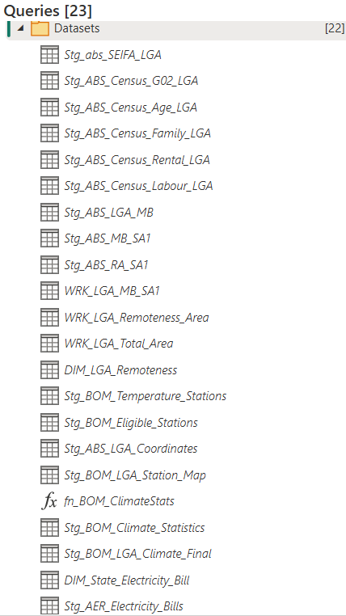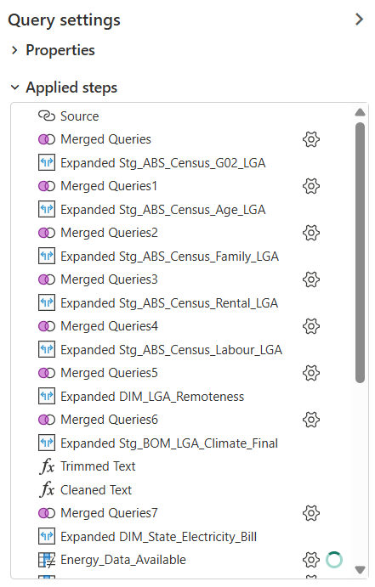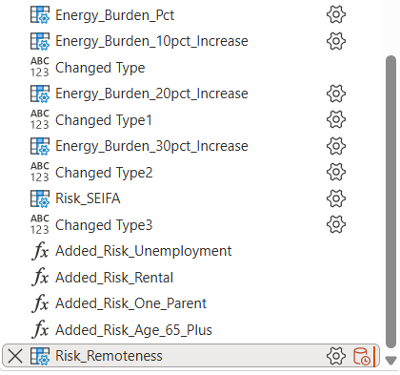
Source: Author's own work
With the single base, a descriptive analysis was created in Power BI, which allowed to compare LGAs and calculate the Energy Burden, the Energy Burden is how much the annual cost of electricity corresponds to the median annual income of the region. This measure is relevant to assess the difficulty of energy accessibility in relation to the income of each LGA (ECA 2025; AER 2025).
To understand what the energy hardship patterns would be, an analysis was made using the Consumer Energy Report Card Household Survey, with 4,106 households (ECA 2026). These data were used in Orange for a predictive analysis, comparing between Logistic Regression and Random Forest. Finally, the unique base created in Power BI with the 547 LGAs and seven standardized vulnerability indicators to find the pattern among the LGAs was also used in Orange. The K-Means clustering algorithm was used. Details on configuration and evaluation of the models are available in Appendix A.
Figure 2: - Predictive analytics workflow developed in Orange Data Mining
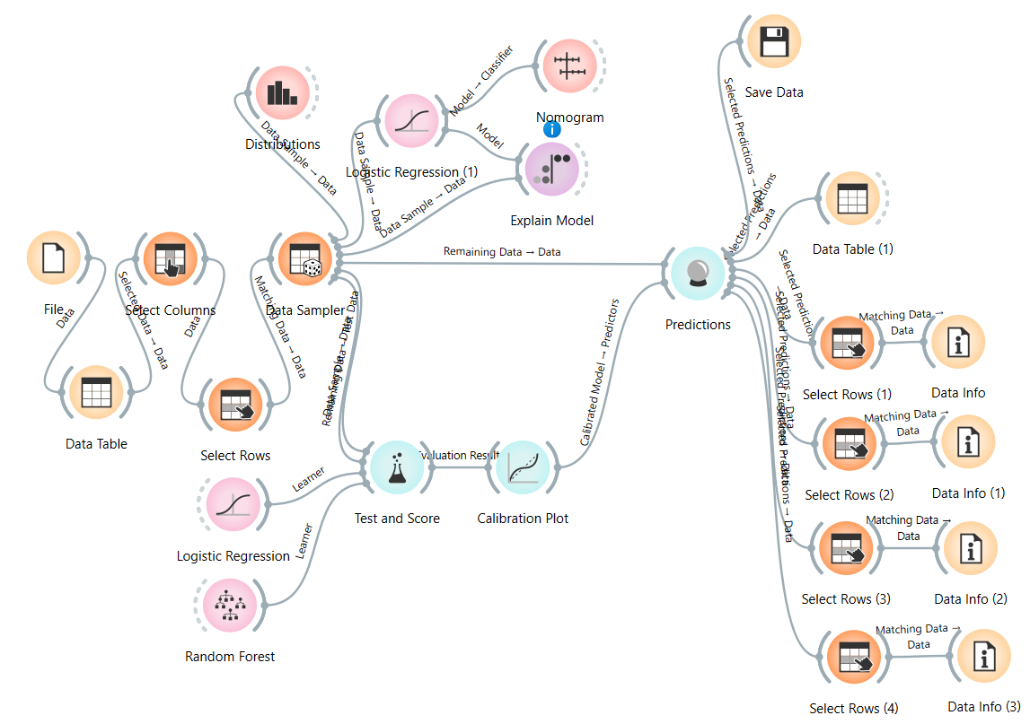
Source: Author's own work

Data Analytics Methodology
To answer the different parts of the business question, the methodology was organized in stages. First, in Power BI a descriptive analysis was made comparing LGAs, observing the main vulnerability indicators and analysing the Energy Burden. Then, to analyse the LGAs' sensitivity amid increases in energy prices, hypothetical scenarios of 10%, 20% and 30% (were defined by the project and not as a future forecast) of increase in electricity price while maintaining the rent value, with these breaks it was possible to see if there would be pressure on family budgets.
As a complementary predictive analysis, 4,106 families were analysed from the Consumer Energy Report Card Household Survey. The intention was to explore characteristics associated with energy hardship at the level of households and by LGAS. these data were compared using the Logistic Regression and Random Forest models. The best overall performance and easiest interpretation was the Logistic Regression, however, this analysis was only complementary, as it was at the level of families which did not help in the interpretation of LGAs. meanwhile helped to understand patterns of vulnerability among families (ECA 2026).
Figure 3: Performance comparison of Logistic Regression and Random Forest in Orange
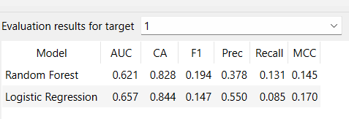
Source: Author’s own analysis using ECA (2026) data.
A new strategy was to analyse the 547 LGAs using K-Means clustering, thus identifying groups with the same characteristics without considering risk classification. In this analysis, seven indicators were considered: socioeconomic disadvantage, unemployment, rent, single-parent families, population over 65 years of age, remoteness and climate. Cluster numbers between two and six were tested, using the Silhouette Score to compare quality across groups. The number of clusters that presented the best result was 2 clusters and this one was selected for final analysis.
Figure 4: K-Means cluster evaluation using Silhouette Score in Orange
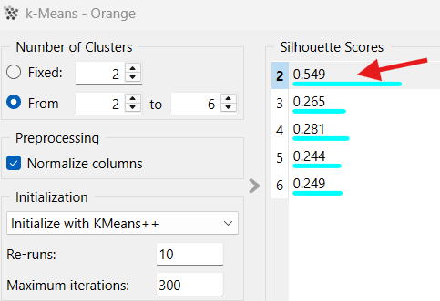
Source: Author’s own analysis
As a result, the clustering integrated into Power BI allowed us to analyse 51 LGAs found in cluster 1, which had the greatest vulnerability, associated with geographical visualization and comparison between groups. This combination of Power BI and Orange has enabled us to bring together descriptive analysis, clustering, and pricing scenarios into a single model to analyse and find a decision support solution. Technical details on variables, validation, model setup and cluster assessment are presented in Appendix A.

Visualisation and Evaluation of Results
In the final view it was identified that the energy vulnerability is not equally distributed among LGAs, the analysis with K-Means separated the LGAs into 2 groups and found 51 LGAs with a higher profile of multidimensional vulnerability. Of the 51 LGAs, approximately 92% are in Queensland, Western Australia and the Northern Territory, in Figure 5 shows the result where these areas are concentrated. It is important to inform that the analysis does not confirm that these LGAs are in a situation of energy poverty but helps to indicate regions where the study vulnerability factors appear at the same time, i.e. leaving the exploitation more focused.
Figure 5: LGA vulnerability clustering results in Power BI
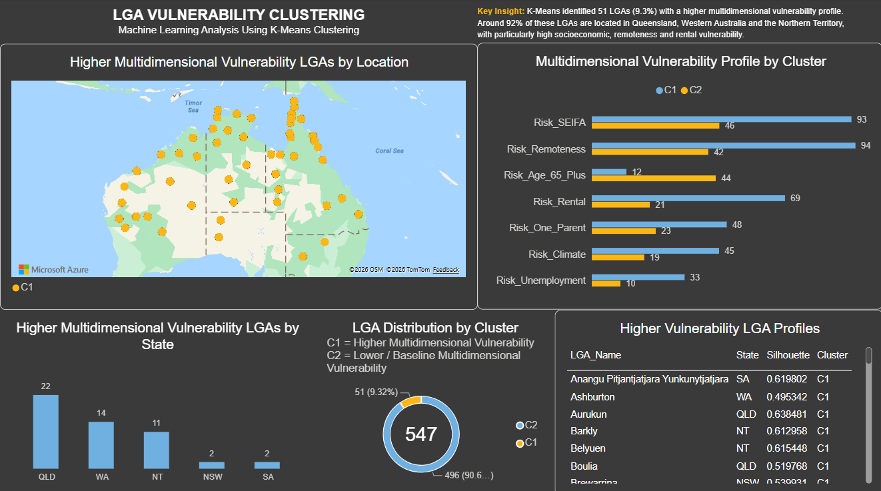
Source: Author's own analysis
Cluster 1 showed higher average values of socioeconomic disadvantage, remoteness, rent, unemployment, single-parent families and climate vulnerability. The indicator that showed the lowest average value was the population over 65 years of age, which presented the highest value in Cluster 2. Figure 6 shows that considering a vulnerable LGA does not depend on just one factor; to identify it is necessary to combine different social factors, economic and geographical.
Figure 6: Multidimensional vulnerability profile by K-Means cluster.
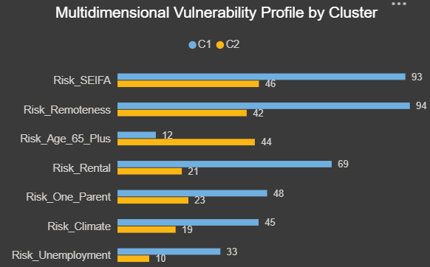
Source: Author's own analysis
The predictive analysis at the household level reinforced the regional results by identifying characteristics associated with the estimated probability of energy hardship. In Figure 7 it is noted that living on rent, living alone and having more children help in increasing the forecast of energy hardship. However, these results are not cause and effect, but only an association found by the model, and this model was only to understand the family-level standard and not for classification of LGAs.
Figure 7: Contribution of household characteristics to predicted Energy Hardship using Logistic Regression.
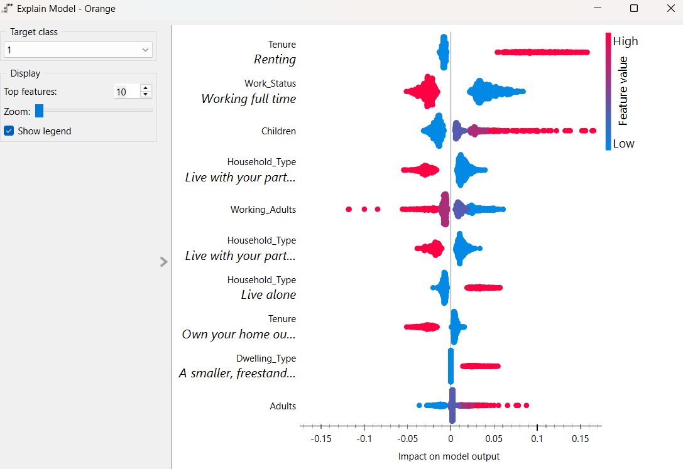
Source: Author's own analysis using ECA (2026) data.
Comparing LGAs in the current scenario and with hypothetical scenarios and separating by groups found in clustering reinforces the difference between the groups. In the current scenario, the average Energy Burden was 3.0% for all LGAs and 3.9% for the LGAs found in Cluster 1. Analysing with a hypothetical increase of 30%, this difference becomes even larger at 3.9% for all LGAs and 5,1% for Cluster 1 only. This shows that LGAs that already present a vulnerability in the current scenario may suffer further financial pressure if energy prices rise.
Figure 8: Energy Burden comparison between all LGAs and the higher-vulnerability cluster under electricity price scenarios.
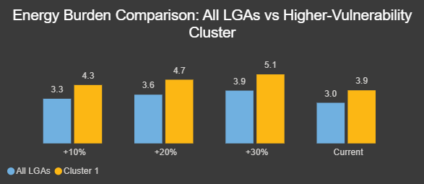
Source: Author’s own analysis.
The combination of the Orange result in Power BI turned the technical result into interpretable visualizations. In Orange the LGAs were compared using a predictive model, the quality of the clusters was evaluated, and it was identified which characteristics helped for the prediction of energy hardship. In Power BI this comparison became even easier with the result of the applied Orange, it was easier to buy and view the cluster LGAs on the map and analyse them in scenarios of electricity price increase. Each tool in the project had a different function: Orange supported statistical and machine learning analysis, and Power BI helped to combine the Orange outcome clearly. However, the results should be considered only as support and not as a definitive classification.

Recommendations
The first recommendation is to use the 51 LGAs found in Cluster 1 as a priority group for more detailed research, rather than an automatic classification of energy poverty. These regions have higher levels in vulnerability indicators, so the result can be considered as an initial step of screening for more detailed studies, helps to assess where support measures may be most needed. The ECA (2025) highlights that it is important to improve the identification of households in energy hardship, as this helps better direct public resources.
The second recommendation is to improve the availability of local energy data, because the project needed to gather information from different sources and geographical levels and also electricity costs were not separated by LGA. The AER (2025) already uses indicators related to debt and household difficulties in tracking energy prices, which shows relevance in monitoring the problem, so it is necessary that the data are more detailed, mainly about consumption, debt and participate in hardship programs.
The third recommendation is to use the dashboard to track how changes in electricity prices can affect areas with greater vulnerability. As seen in Figure 8, the LGAs found in Cluster 1 may suffer greater financial pressure in increase scenarios, this increase may be caused by climate change with high or extremely low temperatures, so it is necessary to continue monitoring (Li et al. 2024).
In a next phase the prototype could be transformed into an integrated tool for regular updating and integrate aggregated or de-identified data from different organizations. However, this integration must occur with quality rules, validation and data governance standardized and in accordance with the law (AEMO 2024). The current data integrated into Power BI are from different periods and some electricity costs represent state or regional averages, and there is also the issue of the climatic point that is used the region closest to the LGA, so these results need to be interpreted carefully. Therefore, it cannot replace human analysis and rely only on the results achieved by the tool.

Data Ethics and Security
Public data were used in this project, and no individual was identified in the analyses. In the Consumer Energy Report Card Household Survey, no personal identifiers were used in the models. It is important to make clear that the LGAs found in Cluster 1 do not confirm energy poverty for these regions and that the upside scenarios are only a sensitivity test and not a future forecast.
In a future update of data including data from retailers, it would be necessary to use aggregated or de-identified data, establish clear data security, privacy and governance rules to control access to personal information (OAIC 2025). And the final decisions must continue under human supervision and not only take into account what the tool showed.

Reference List
- Australian Bureau of Statistics [ABS] 2021a, ‘Search Census data’, ABS, viewed 24 July 2026 <https://www.abs.gov.au/census/find-census-data/search-by-area>.
- Australian Bureau of Statistics [ABS] 2021b, ‘Socio-Economic Indexes for Areas (SEIFA), Australia’, ABS, viewed 24 July 2026 <https://www.abs.gov.au/statistics/people/people-and-communities/socio-economic-indexes-areas-seifa-australia/latest-release>.
- Australian Bureau of Statistics [ABS] 2021c, ‘Remoteness Areas: Australian Statistical Geography Standard (ASGS)’, ABS, viewed 24 July 2026 <https://www.abs.gov.au/statistics/standards/australian-statistical-geography-standard-asgs/edition-3-july-2021-june-2026/remoteness-structure/remoteness-areas>.
- Australian Energy Market Operator [AEMO] 2024, ‘CER Data Exchange Industry Co-Design’, Australian Energy Market Operator, October 2024, viewed 1 Oct 2026 < https://www.aemo.com.au/-/media/files/initiatives/der/2024/cer-data-exchange---consultation-paper---oct-2024.pdf>.
- Australian Energy Regulator [AER] 2025, ‘State of the Energy Market 2025: Retail energy markets and energy consumers’, Australian Government, viewed 25 July 2026 <https://www.aer.gov.au/system/files/2025-08/State%20of%20the%20energy%20market%202025%20-%20Chapter%206%20-%20Retail%20energy%20markets%20and%20energy%20consumers.pdf>.
- Bureau of Meteorology [BOM] 2026, Climate Data Online, Australian Government, viewed 25 July 2026 <https://www.bom.gov.au/climate/data/>.
- Chandrashekeran, S., Noka, V., Bouzarovski, S. 2022, ‘Energy Poverty: Measurement and Governance in Europe and Lessons for Australia’, The Australian Economic Review, Wiley Online Library, 24 Nov., viewed 25 July 2026 <https://onlinelibrary.wiley.com/doi/full/10.1111/1467-8462.12491>.
- Energy Consumers Australia [ECA] 2025, ‘Consumer Energy Report Card: Understanding and measuring energy hardship in Australia’, Energy Consumers Australia, 28 July, viewed 24 July 2026 <https://energyconsumersaustralia.com.au/our-work/surveys/consumer-energy-report-card-understanding-measuring-energy-hardship-australia>.
- Energy Consumers Australia [ECA] 2026, ‘Consumer Energy Report Card data’, Energy Consumers Australia, viewed 24 Aug 2026 <https://energyconsumersaustralia.com.au/our-work/surveys/consumer-energy-report-card-data#heading-1612>.
- Li, A., Toll, M. & Bentley, R. 2024, ‘The risk of energy hardship increases with extreme heat and cold in Australia’, Communications Earth & Environment, vol. 5, article 595, viewed 25 July 2026 <https://www.nature.com/articles/s43247-024-01729-5>.
- Office of the Australian Information Commissioner [OAIC] 2025, ‘Chapter 11: APP 11 Security of personal information’, Australian Government, updated 3 October 2025, viewed 01 Oct 2026 <https://www.oaic.gov.au/privacy/australian-privacy-principles/australian-privacy-principles-guidelines/chapter-11-app-11-security-of-personal-information>.
- Prakash, K, Churchill, S & Smyth, R, 2025, ‘Perception and Reality of Energy Poverty in Australia: Do They Shape Voting Intentions?’, The Australian Economic Review, vol 58, no. 2, pp. 131-139, viewed 01 Oct 2026 <https://onlinelibrary.wiley.com/doi/10.1111/1467-8462.70011>.
- RMIT University 2023, ‘One in four households struggle to pay power bills: five ways to tackle hidden energy poverty’, 2 May, viewed 27 July 2026 <https://www.rmit.edu.au/news/all-news/2023/may/hidden-energy-poverty>.

Appendix A - Technical Analytics Methodology
A.1 Predictive Model Variables
The ECA report (2026) was used, which contains 4,106 houses. A target variable was created for the model with the name Energy_Hardship, with value of 1 when the house had at least one of the energy difficulty indicators presented in the survey and was considered 0 when none of these indicators were found.
In the model, the following variables were used; the others were disregarded because they were used to create the Energy_Hardship variable. This decision was made to avoid data leakage, which can occur when the model receives information that it already has. direct or indirect, because the answer the model must learn by itself.
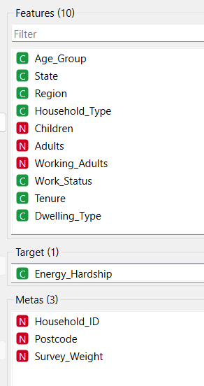
A.2 Model Configuration
To compare the LR and RF models 5-fold stratified cross-validation was used, in this process the data were divided into 5 parts, maintaining the same proportion and without energy_hardship in each group. Each round four parts were used to train and validate, repeating 5 times. This approach was chosen because the data were unbalanced, there were fewer cases of energy_hardship than cases without.
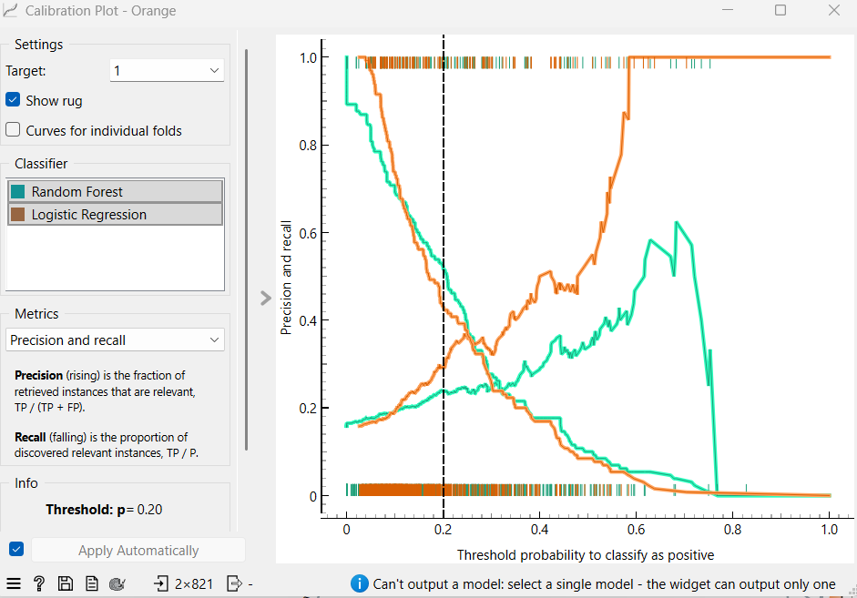
It was also created a division of 80% training to 20% evaluation, so it was possible to analyse the behaviour of models at different limits.
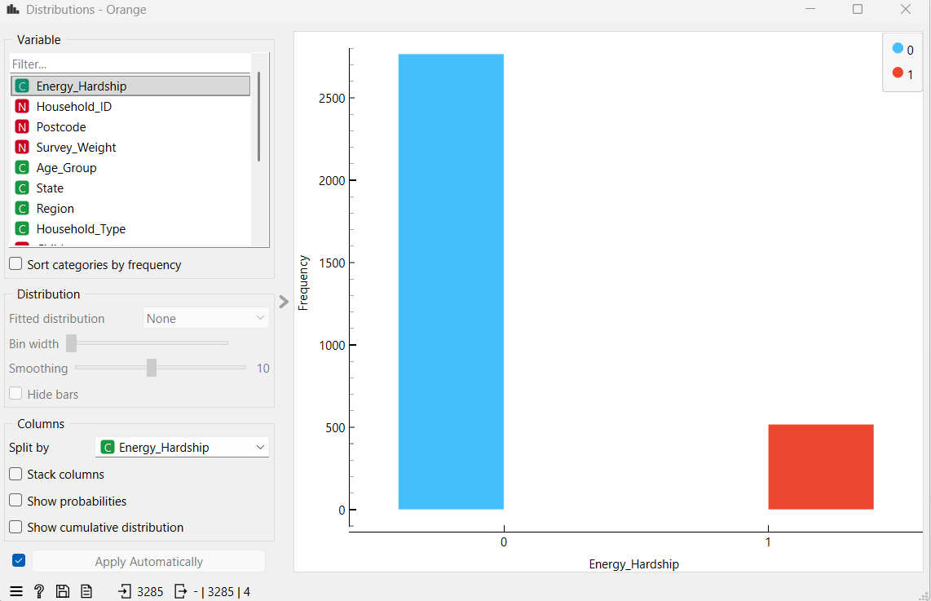
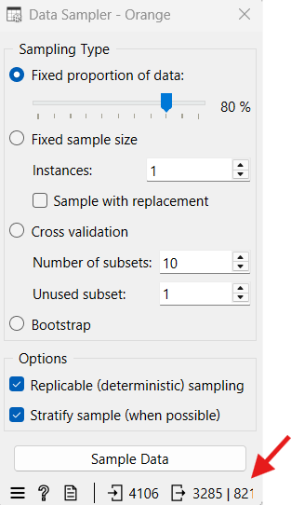
A.3 Predictive Model Results
The result showed that LR had the best result, and with the threshold adjusted to 0.20 increased the identification of households with signs of energy_hardship but also increased the number of false positives.
A.4 K-Means Configuration
The K-Means algorithm was tested with different numbers from 2 to 6, to identify groups of LGAs or any risk classification defined by the project.
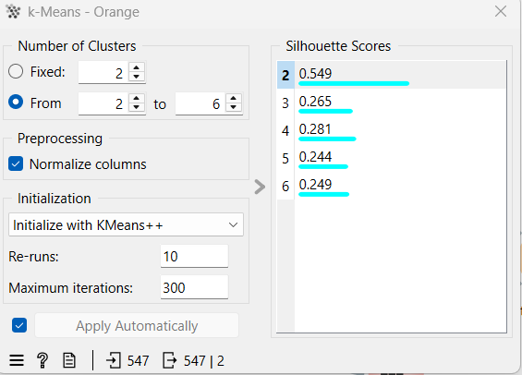
A.5 K-Means Evaluation
The test showed that 2 clusters presented better Silhouette Score. In this result, 51 LGAs with the highest profile of multidimensional vulnerability and 496 LGAs in the second cluster were identified.
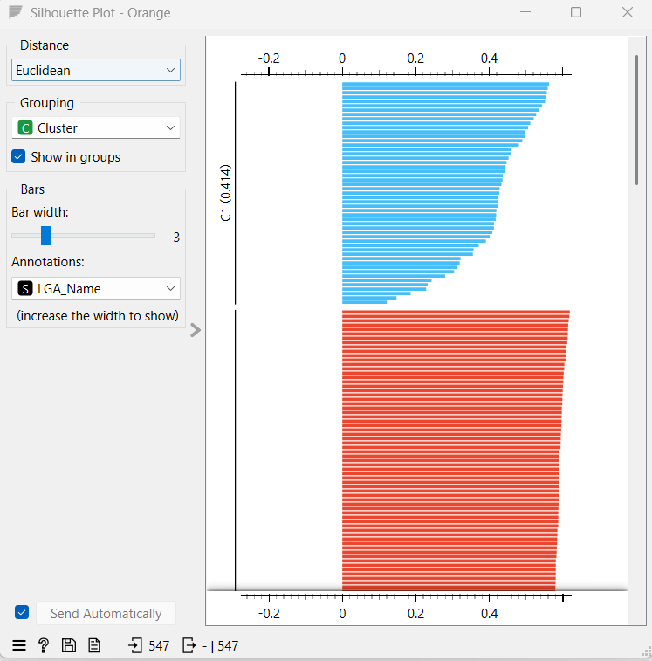

Appendix B – GitHub
Below is the link to access GitHub where will be all the datasets used in this project and also the flows created in Orange and the model created in Power BI.

